BUSINESS BLUEPRINT

Document information
Project Name | VinaTech Smart Manufacturing's order status management system
Module | FI – Financial Accounting
Sub-Module | AR - Account Receivable
Created by | DucNM, DatNV
Version | 1.0
Date | 28/2/2026

Table of Contents

1. OVERVIEW 4
1.1. Scope 4
1.2. Glossary 4
1.3. Flow chart shapes usage 4
2. Account Receivable Master Data 6
2.1. Customer Account Group 6
2.2. Payment Term 6
2.3. Customer Payment Methods 7
3. Business Processes AR 8
3.1. FI-MD-AR-01 : Customer Down Payment 8
3.2. FI-BP-AR-02 : Account Receivable Down Payment Clearing 10
3.3. FI-BP-AR-03 : Customer Invoice Posting 11
3.4. FI-BP-AR-04: AR Invoice (Integration FI&SD) 14
3.5. FI-BP-AR-05 : Customer Incoming Payment - Full, Partial Payment 16
3.6. FI-BP-AR-06 : Account Receivable Reporting 18

OVERVIEW

Scope
This document describes the business processes and configuration of the FI–AR (Accounts Receivable) module in SAP S/4HANA for VinaTech Smart Manufacturing.
The scope includes:
- Customer Master Data configuration
- Payment Terms and Payment Methods
- Customer Invoice posting
- Incoming Payment processing
- AR Reporting and reconciliation

Glossary
Term | Definition | Note
FI | Financial | SAP Finance Module
GL | General Ledger | Main accounting ledger
AP | Account Payable | Customer accounting
SD | Sales & Distribution | Sales module
COA | Chart of Accounts | Structure of G/L accounts
VAS | Vietnam Accounting Standard | Local accounting standard

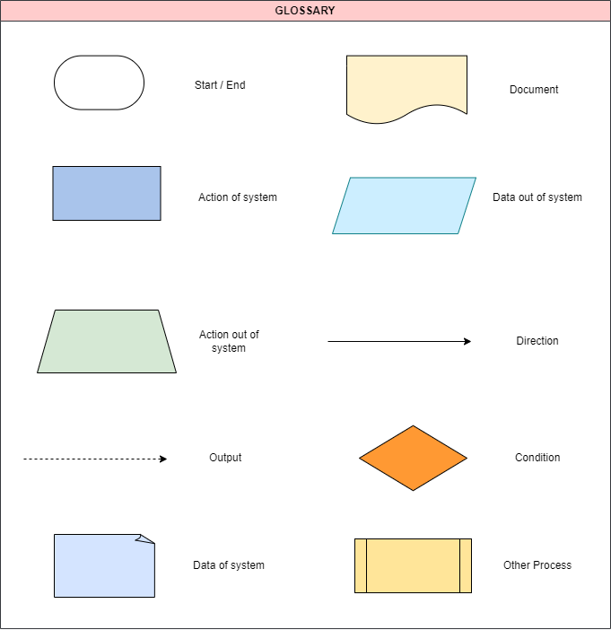
Flow chart shapes usage

Account Receivable Master Data

Customer Account Group
Customer Account Group in SAP is used to classify customers and control:
- Number range assignment
- Field status (mandatory / optional fields)
- Partner determination
- Reconciliation account assignment
Benefits of Customer Account Group:
- Standardize customer data structure
- Separate Retail, Wholesale, and One-time customers
- Support automatic account determination

Account Group | SAP Description
ZDRC | Domestic Retail Customers
ZDWC | Domestic Wholesale Customers
ZOTC | One-Time Customers

Payment Term
Payment Term defines:
- Baseline date calculation
- Due date
- Cash discount percentage
- Payment block logic
Role of Payment Term in AR:
- Control due date calculation
- Support cash discount management
- Support aging and dunning

Payment Terms | Description
0001 | Payable immediately – Net
0002 | Net 30 days, 2% Discount within 14 days
0003 | 3% Discount within 14 days, 2% Discount within 20 days  Net 30 days

Customer Payment Methods
Customer Payment Method is defined to control:
- Incoming payment processing
- Bank selection during automatic payment program
- Clearing logic
Payment Method | Description
E | Cash
T | Bank Transfer

Business Processes AR

FI-BP-AR-01 : Customer Down Payment
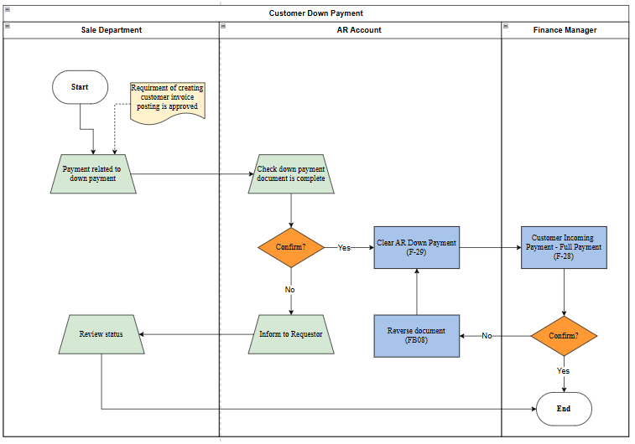
Business flow process :

Process Description:
Step | Step Name | Detailed Description | Role
1 | AR request with supporting documents | Input: Request supporting documents  Explain: An authorized person reviews supporting document requests before initiating the return process.  Output: Request is approved | Request Department
2 | Check if documents for down payment is complete | Input: Documents for down payment  Explain: Check and confirm documents related to down payment are correct or not?  If correct, move to step 3  If not, inform requestor | AR Accountant
3 | Clear AR Down Payment | Input: Documents for down payment  Explain: Perform clear AR Down Payment in SAP system (Transaction code F-29)  Output: AR Down Payment | AR Accountant
4 | Review AR document | Input: Documents for down payment  Explain: Check AR document and approve or not  If approve, end process  If not approve, reverse document | Finance Manager
5 | Reverse document | Input: Documents for down payment  Explain: Perform reverse document through Transaction code FB08 | AR Accountant
6 | Inform to Requestor | Inform to requestor about document related to down payments that is not correct | AR Accountant
7 | Review Status | Review and check status of customer down payment | Request Department

FI-BP-AR-02 : Account Receivable Down Payment Clearing
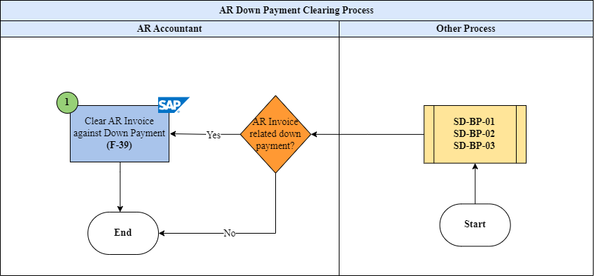
Business flow process :

Process Description:FI-BP-AR-03 : Customer Invoice Posting

Step | Step Name | Detailed Description | Role
1 | Verify Invoice & Down Payment | Input: Based on two outputs of the Sale Distribution Process to confirm yes or no that AR Invoice-related down payment  Explain:  If AR Invoice is related to down payment, AR Accountant will do step 1.  If not, the process will end.  Transaction code F-39  Output: Request is approved | AR Accountant
 | Execute Down Payment Clearing (F-39) | Input: Invoice number and Down Payment document.  Explain: AR Accountant performs clearing using transaction code F-39 to transfer down payment amount to invoice.  Accounting Entry:  Dr Customer Down Payment (Special G/L A)  Cr Customer (Normal AR line item)  Output: Down payment cleared against invoice. | AR Accountant
 | Display Cleared Items (FBL5N) | Input: Customer account.  Explain: Review cleared and open items using FBL5N to ensure clearing was successful.  Output: Clearing status verified | AR Accountant
 | End Process | Explain: If no related down payment exists, the process ends without clearing. | AR Accountant
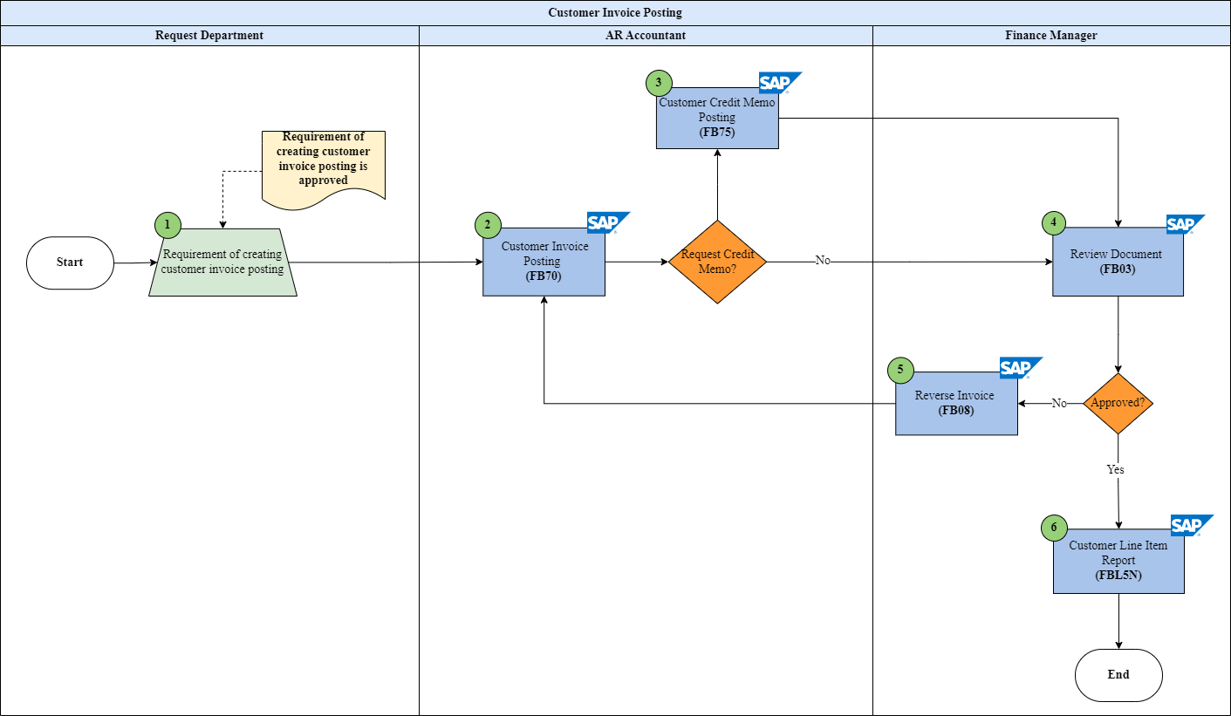
Business flow process:

Process Description:

Step | Step Name | Detailed Description | Role
1 | Submit Invoice Request | Input: Sales order / delivery confirmation / supporting documents.  Explain: Request Department submits request to create customer invoice.  Output: Invoice request forwarded to AR Accountant. | Request Department
2 | Post Customer Invoice (FB70) | Input: Approved invoice request.  Explain: AR Accountant posts customer invoice using transaction code FB70.  The system checks customer master data, reconciliation account, and tax code.  Accounting Entry:  Dr Customer (AR)  Cr Revenue  Cr Output VAT  Output: Customer invoice document created. | AR Accountant
3 | Review Invoice Document (FB03) | Input: Posted invoice document.  Explain: Finance Manager reviews the accounting document via FB03 to ensure correctness of amount, tax, and account determination.  Output: Invoice approved or rejected. | Finance Manager
4 | Reverse Invoice (if required) | Input: Incorrect invoice document.  Explain: If errors are found, the Finance Manager performs a reversal using FB08.  Output: Reversal document created. | Finance Manager
5 | Reverse Invoice | Input: Customer Invoice  Explain: Perform reverse document through Transaction code FB08 | Finance Manager
6 | Display Customer Line Items (FBL5N) | Input: Customer account.  Explain: Review open items and invoice balance using FBL5N.  Output: Invoice status verified. | Finance Manager

FI-BP-AR-04: AR Invoice (Integration FI&SD)
Business flow process:
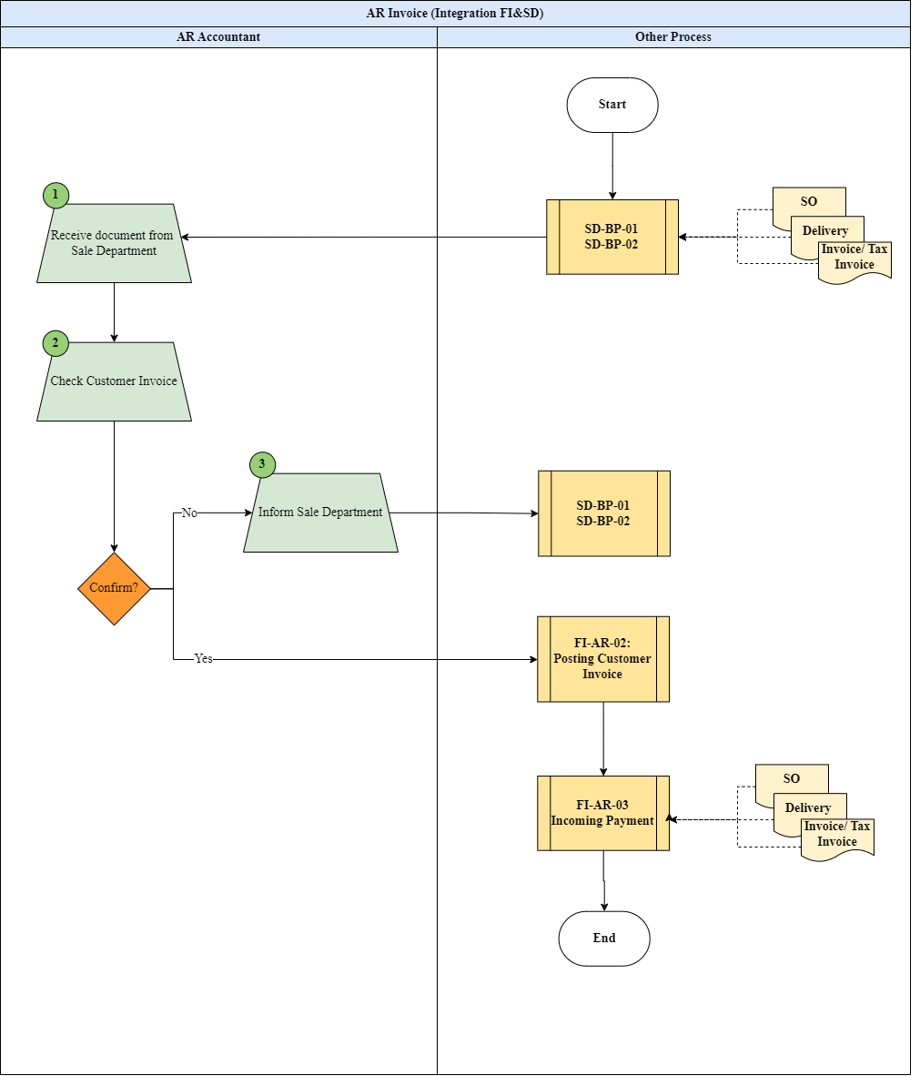
Process Description:

Step | Step Name | Detailed Description | Role
1 | Create Delivery (SD) | Input: Sales Order.  Explain: Sales Department creates delivery documents in SD after goods are ready for shipment.  Output: Delivery document created. | Sales Department
2 | Post Goods Issue (PGI) | Input: Delivery document.  Explain: Goods Issue is posted, reducing inventory and recording Cost of Goods Sold.  Accounting Entry (Automatic):  Dr COGS  Cr Inventory  Output: Inventory updated. | System
3 | Create Billing Document (VF01) | Input: Delivery document.  Explain: Billing document is created in SD using VF01.  The system automatically generates accounting documents in FI.  Output: Billing document created. | Sales Department
4 | Automatic FI Posting | Explain: When a billing document is saved, SAP automatically creates a FI document.  Accounting Entry:  Dr Customer (AR Reconciliation Account)  Cr Revenue  Cr Output VAT  Output: FI document posted. | System
5 | Review Accounting Document (FB03) | Input: FI document number.  Explain: AR Accountant reviews accounting documents in FI via FB03.  Output: Posting verified. | AR Accountant
6 | Display Customer Line Items (FBL5N) | Input: Customer account.  Explain: Review open invoice items using FBL5N.  Output: Invoice status confirmed. | AR Accountant

FI-BP-AR-05 : Customer Incoming Payment - Full, Partial Payment
Business flow process:
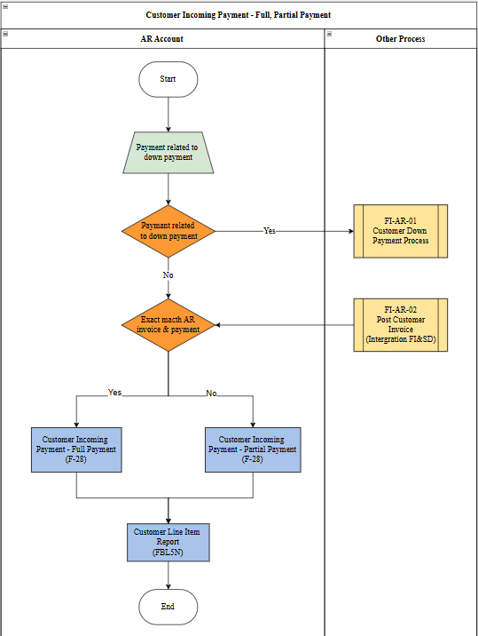

Process Description:
Step | Step Name | Detailed Description | Role
1 | Receive Customer Payment | Input: Bank statement / payment advice.  Explain: AR Accountant receives payment from customer and verifies payment reference (invoice number, amount).  Check whether payment relates to down payment or invoice.  Output: Payment ready for processing. | AR Accountant
2 | Determine Payment Type | Input: Customer open items.  Explain: Compare payment amount with outstanding invoice amount.  If payment = invoice amount → Full Payment.  If payment < invoice amount → Partial or Residual Payment.  Output: Payment type identified. | AR Accountant
3A | Post Full Payment (F-28) | Input: Customer invoice & payment amount.  Explain: Use transaction code F-28 to post and clear invoice fully.  Accounting Entry:  Dr Bank  Cr Customer (AR)  Output: Invoice cleared, balance = 0. | AR Accountant
3B | Post Partial Payment (F-28 – Partial) | Input: Invoice & partial amount.  Explain: Post partial payment using F-28 and select Partial Payment option.  Original invoice remains open with reduced balance.  Accounting Entry:  Dr Bank  Cr Customer (Partial clearing)  Output: Invoice partially cleared, remaining balance open. | AR Accountant
4 | Display Customer Line Items (FBL5N) | Input: Customer account.  Explain: Verify clearing status using FBL5N to confirm open and cleared items.  Output: Payment status confirmed. | AR Accountant

FI-BP-AR-06 : Account Receivable Reporting
Business flow process:

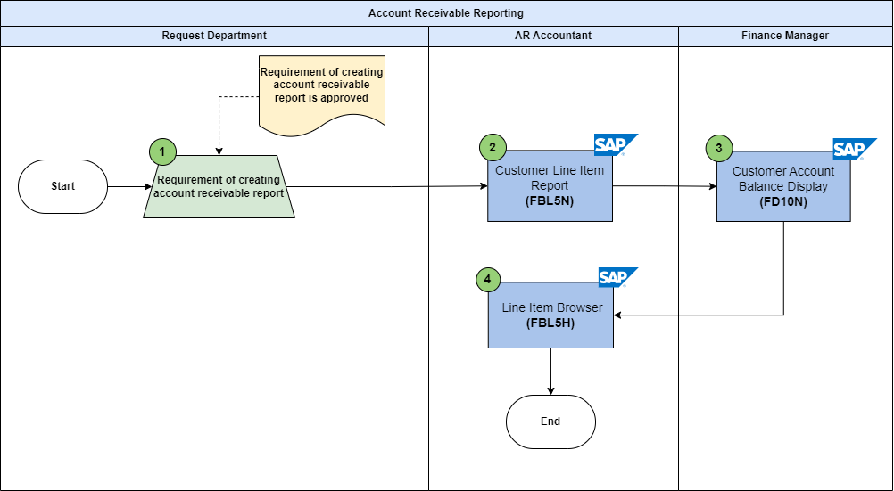
Process Description:
Step | Step Name | Detailed Description | Role
1 | Submit AR Reporting Request | Input: Request for AR report.  Explain: Request Department submits request to generate Account Receivable report for monitoring outstanding balances.  Output: Reporting request approved. | Request Department
2 | Display Customer Line Items (FBL5N) | Input: Customer account.  Explain: AR Accountant uses FBL5N to review open items, cleared items, and customer balances.  Filter by company code, posting date, and customer number.  Output: Detailed AR line item list generated. | AR Accountant
3 | Display Customer Balance (FD10N) | Input: Customer master data.  Explain: Use FD10N to display customer account balance including debit, credit, and total balance.  Output: Customer balance overview. | AR Accountant
4 | Aging Analysis | Input: Open items report.  Explain: Analyze overdue invoices using aging buckets (0-30, 31-60, 61-90 days, etc.).  Used for credit control and collection management.  Output: AR aging report generated. | AR Accountant
5 | Line Item Display (FB03) | Input: Specific document number.  Explain: Finance Manager reviews individual accounting documents using FB03.  Output: Document detail verified. | Finance Manager

